

# MongoDB Training: Coding Lab Guide

Our learn-by-doing method enables you to build practical/coding experience that sticks. 95% of our learners say they remember more when they learn by doing hands-on which is required to translate knowledge into real-world results.

The recommended hardware and software requirements for our training are given below:

## Hardware Requirements

* 1.6 GHz or faster processor
* 4 GB or higher RAM
* 20 GB of available hard disk space
* DirectX 9-capable video card that runs at 1024 x 768 or higher display resolution

## Software Requirements

* Windows 10 or higher, Mac or Linux,
* Visual Studio Code Latest Version
* Node.js 16.x or higher
* Git
* Install React CLI after installing Node.js by running the command:
  + npm i -g create-react-app
* Latest Browser i.e. Google Chrome/ FF/IE
* Internet Connectivity

## Software Download Links

* Visual Studio Code: <http://code.visualstudio.com>
* Node.js: <https://nodejs.org/en>
* Git (for Windows): <https://git-scm.com/download/win>

# 1. MongoDB Installation

**MongoDB**is an open-source document-oriented database. It is categorized under the **NoSQL(Not only SQL)**database because the storage and retrieval of data in MongoDB are not in the form of tables. This is the general introduction to MongoDB now we will learn **how to install MongoDB in Windows.**

## Step 1: Go to [MongoDB download Page](https://www.mongodb.com/try/download/community)to download the MongoDB Community Server.

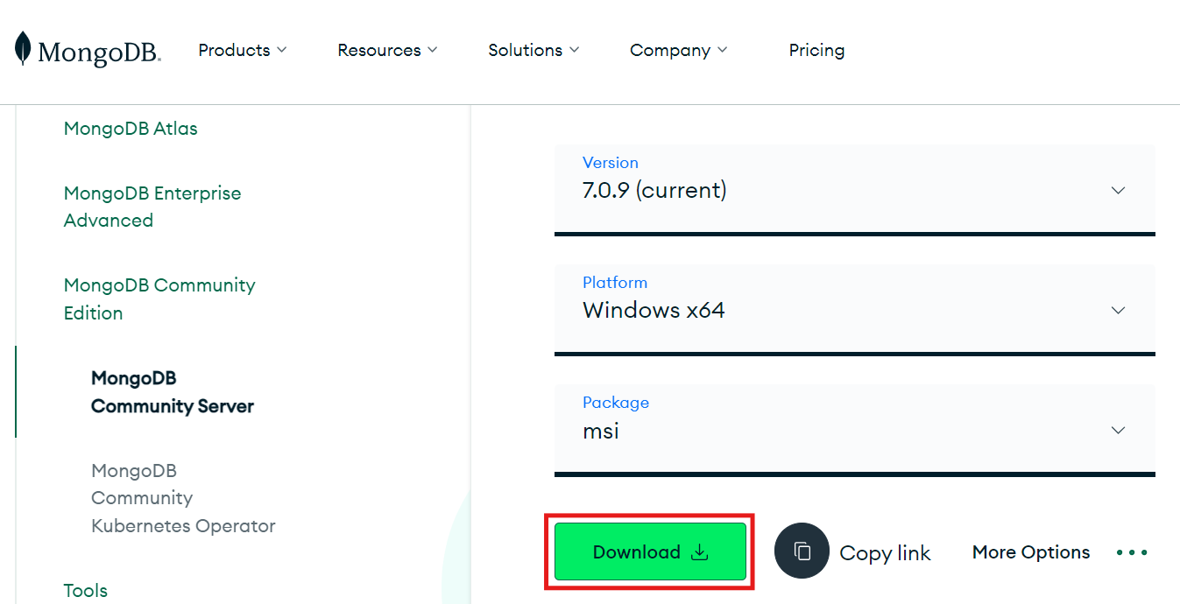

**Here, you can select any version, Windows, and package according to your requirement.**

**For Windows, we need to choose:**

* **Version**: 7.0.4
* **OS**: Windows x64
* **Package**: msi

## Step 2: After Downloading the file from the link, open the msi file and click the next button in startup screen.

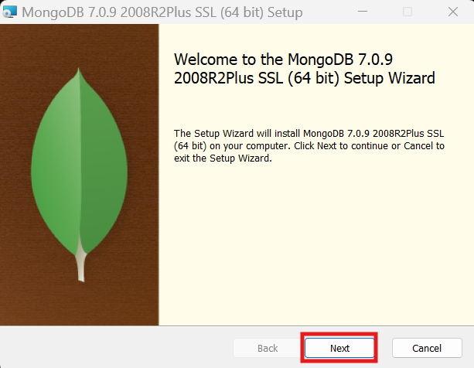

## Step 3: Now accept the End-User License Agreement and click the next button:

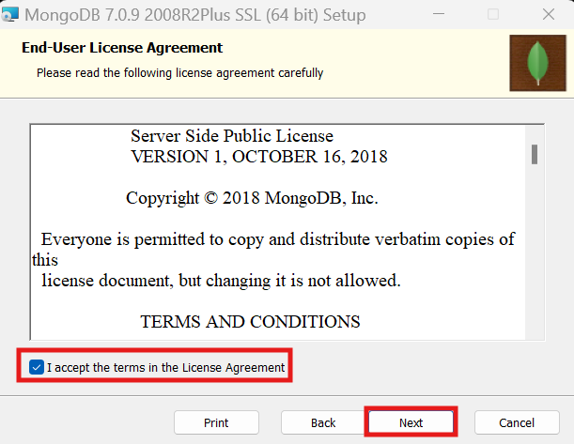

## Step 4: Now select the *complete option*to install all the program features. Here, if you can want to install only selected program features and want to select the location of the installation, then use the*Custom option:*

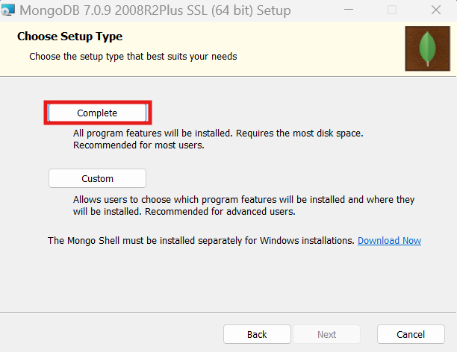

## Step 5: Select “Run service as Network Service user” and copy the path of the data directory. Click Next:

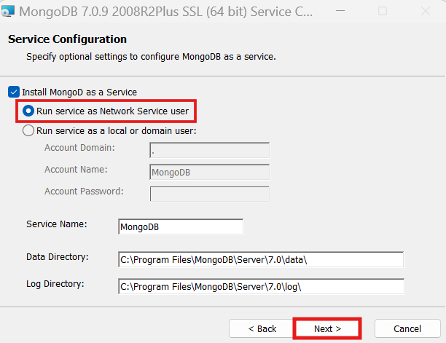

## Step 6: Click on Next button to install MongoDB Compass which is the graphical user interface for MongoDB. Click the checkbox on the bottom left as well.

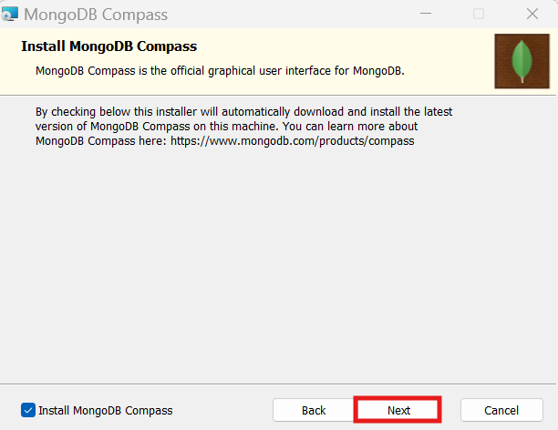

## Step 7: Click the*Install button* to start the MongoDB installation process:

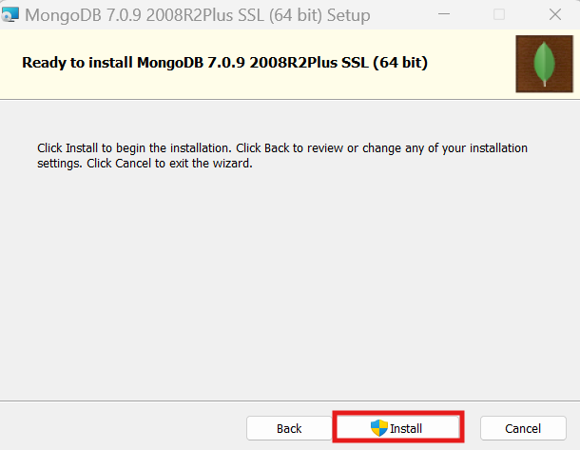

## Step 8: After clicking on the install button installation of MongoDB begins:

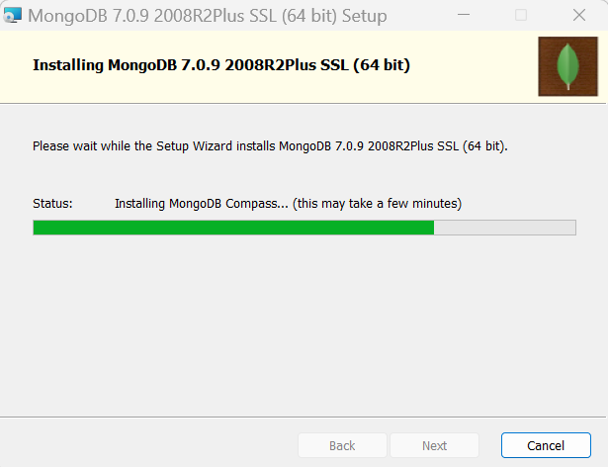

## Step 9: Now clickthe Finish buttonto complete the MongoDB installation process:

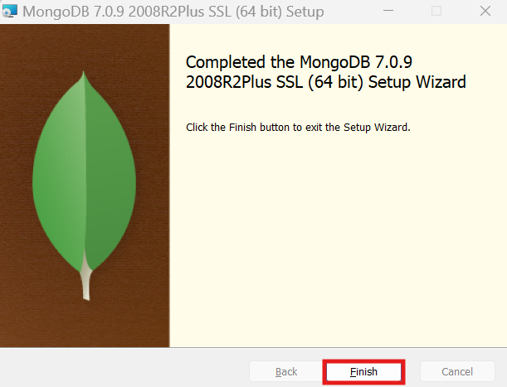

­

# 

## Step 10: Now we go to the location where MongoDB installed in your system and copy the bin path as shown below:

## Step 11: Open Settings and search “Path”.

**The two options given below would pop up in the dropdown:**

1. Edit environment variable of your account.
2. Edit the system environment variable.

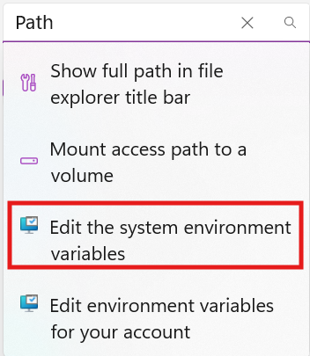

## Step 12: Click on “*Edit the system environment variable*” and then click on ‘*Environment Variables*’.

## Step 13: In the Environment variable, you’ll see the path as given in the snippet. Click ‘Path’ and then press ‘Edit’.

## Step 14: In the Path given at your system, and add new “The copied path” from binaries, and click “*OK*”.

## Step 15: After setting the environment variable, we will run the MongoDB server, i.e. mongod.  So, open the command prompt and run the following command:

mongod

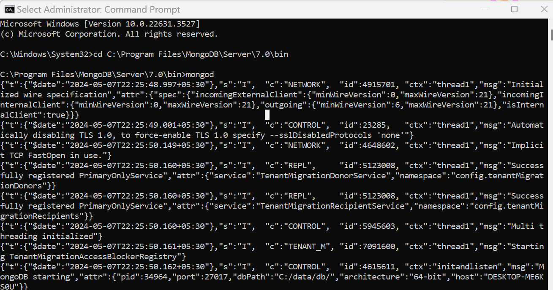

## Step 16: In the previous versions, we have to create a “data” folder in the MongoDB folder manually. But, now from the latest version (7.0), this “data” folder is automatically created in this path: C:\Program Files\MongoDB\Server\7.0

## Step 17: Now, if you remember we have already installed MongoDB Compass in Step-6. Open MongoDB Compass. Now, you’ll see this connection string with the default /localhost:27017/.

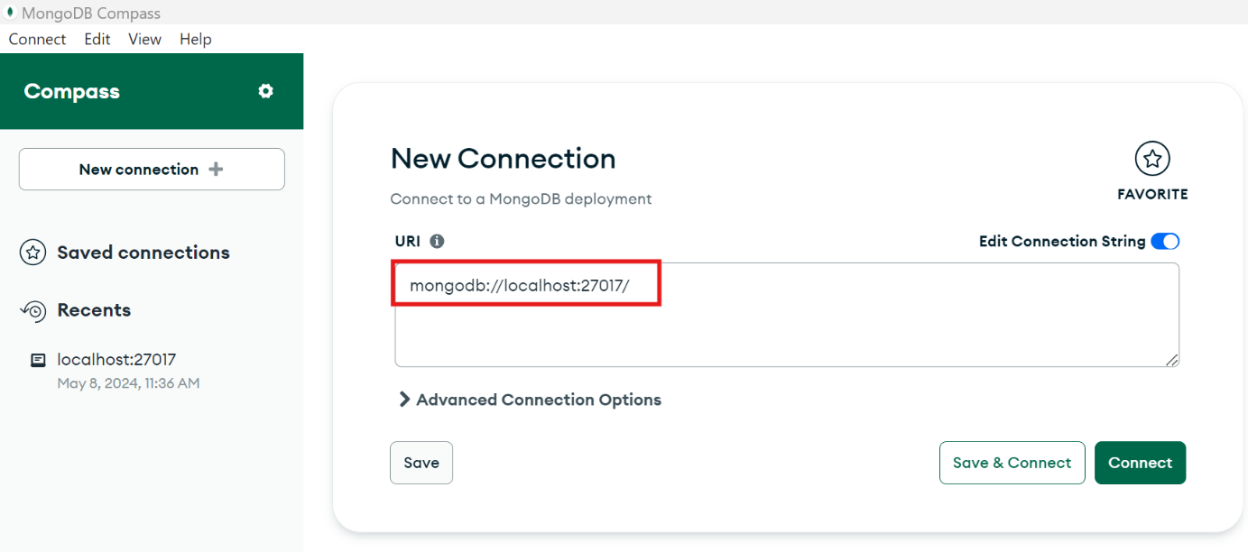

## Step 18: Click on Connect with this connection string.

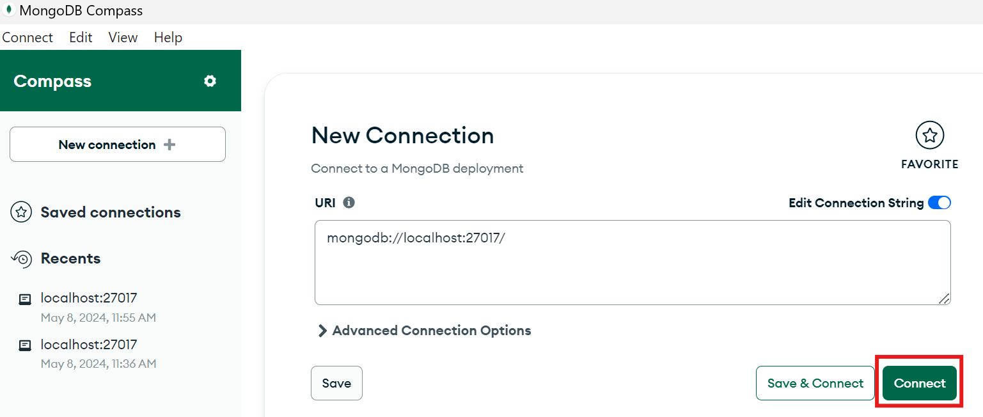

## Step 19: Now, the connection is created and you’ll be redirected to MongoDB Dashboard which will show the entire list of databases that you’ll create in future.

**Congratulations! You’ve successfully Installed and Configured MongoDB.**

# Contact Us

If you are still facing any issues while installing the software and configuring the system, please free to reach out to us at **+91 9999 123 502/503** or email us at [hello@scholarhat.com](mailto:hello@scholarhat.com)